**Assignment Two: Needfinding, POVs, HMWs, and Prototypes**

**Introduction:**

**The Team:**

Eli V., Jake R., Fiona H.Z., David R.B.

**Studio Theme:**

Educational Technology

**Problem Domain:**

Our problem domain is improving enjoyment, frequency, and learning outcomes of class discussions. Our needfinding revealed tension between the convenience and adaptability of technology and the desire for face-to-face interaction, which we explored in depth this week.

**Domain Revision and Point of View (POV) Selection Overview:**

We interviewed a total of 13 people (Participants #0 through #12) over Weeks 1 and 2. In Week 2, we narrowed our focus to the more specific domain of improving quality of class participation and discussion.

**Week 2 — Key Needfinding Interviews:**

Joe (#9) and Nick (#10) were both highschool juniors enrolled in the Middle College Program at Canada College.

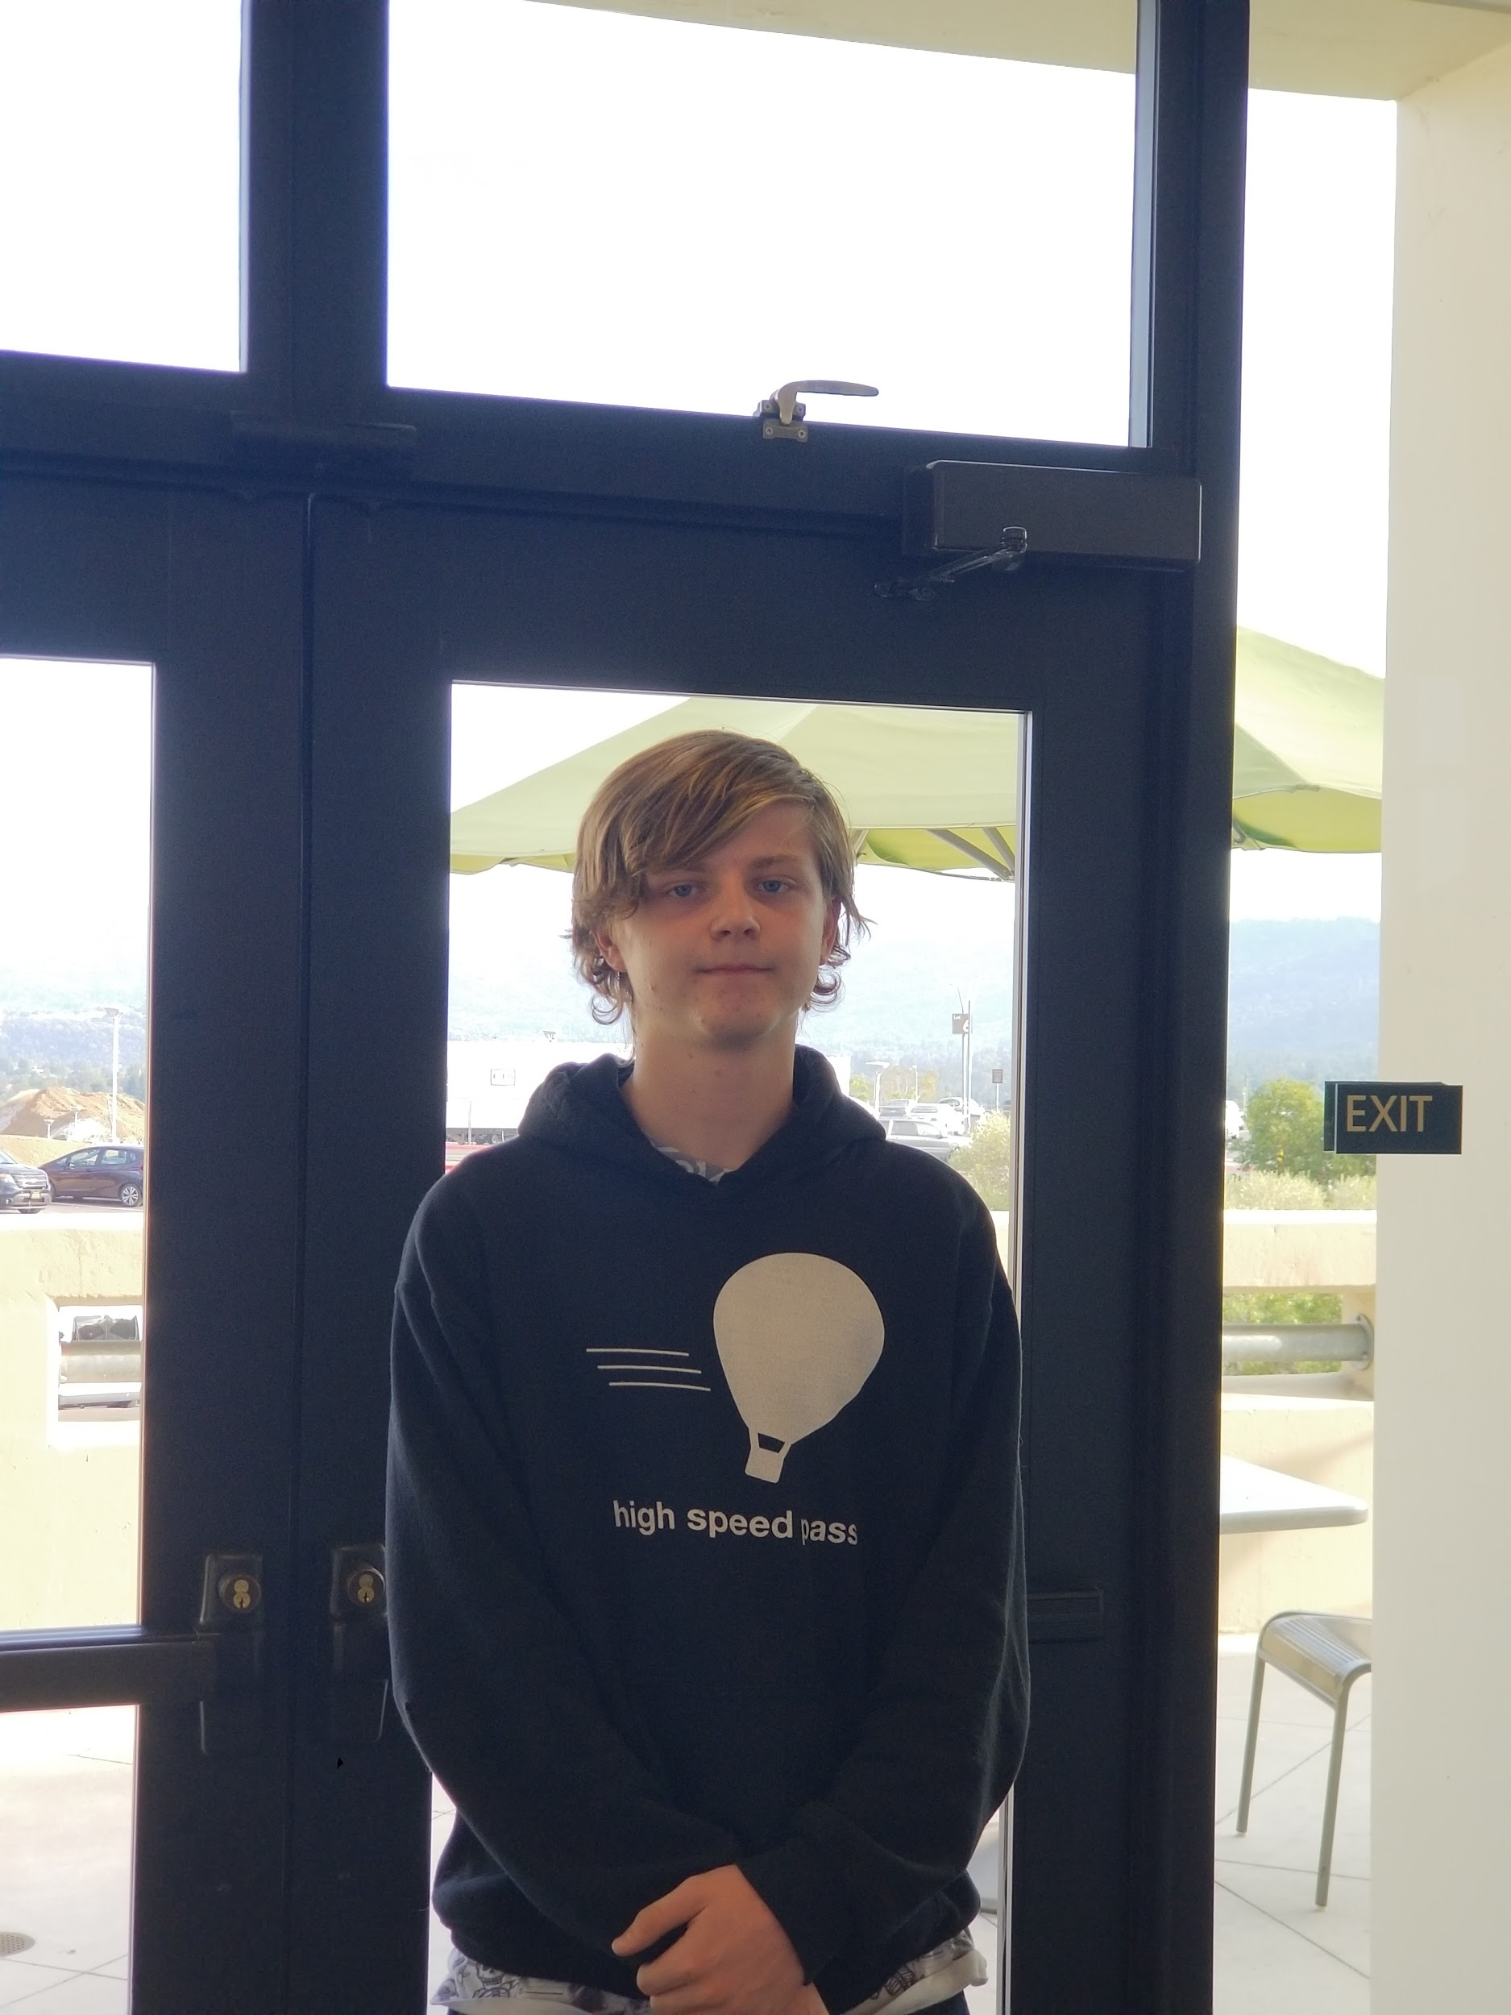

Joe was studying Computer Science. He preferred his online CS course because it’s “easier to access both your code and your class material at the same time.” He contrasted this with his view that humanities courses function better face-to-face because “you have a conversation . . . it’s a little bit more memorable than just reading.”

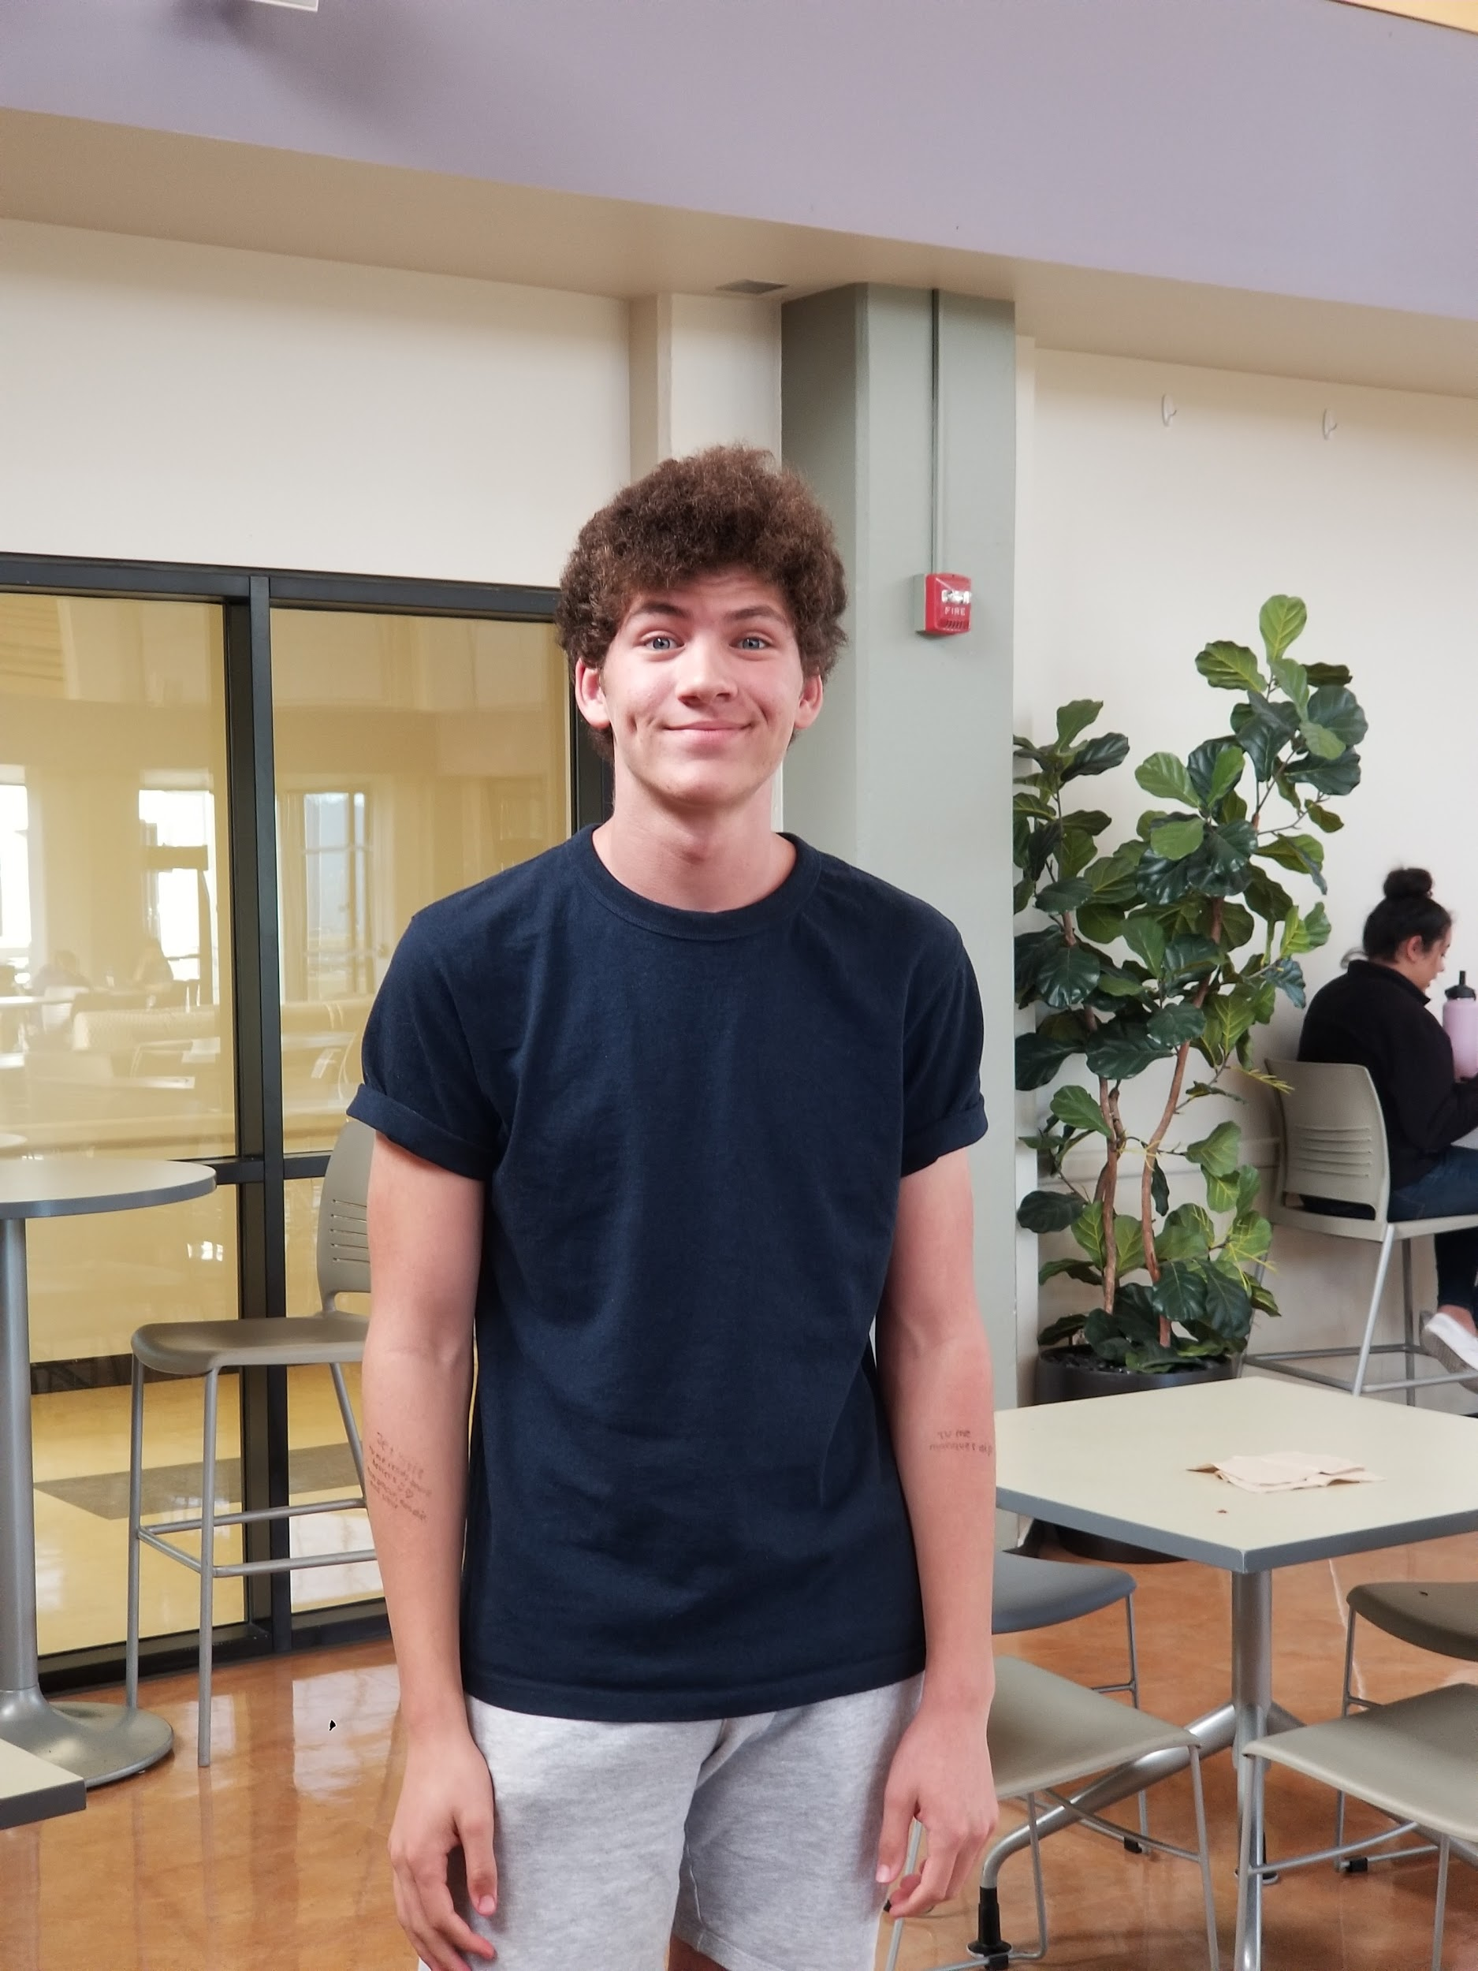

Nick was studying music and film while also taking an online CS course. He focused on the importance of being at a similar skill level with his peers and having a sense of consistency and appropriateness of challenge level as key factors in his motivation to participate. Nick also echoed Joe’s appreciation of discussion as a way of testing his own knowledge.

Janice (#11) was a professor of fiction and nonfiction storytelling. She spoke about building community between students so that they felt confident in sharing their stories in her courses. She also highlighted the importance of setting norms to facilitate equal participation: such as making sure people raise their hands, referencing prior conversations with students, and avoiding interrupting each other. 

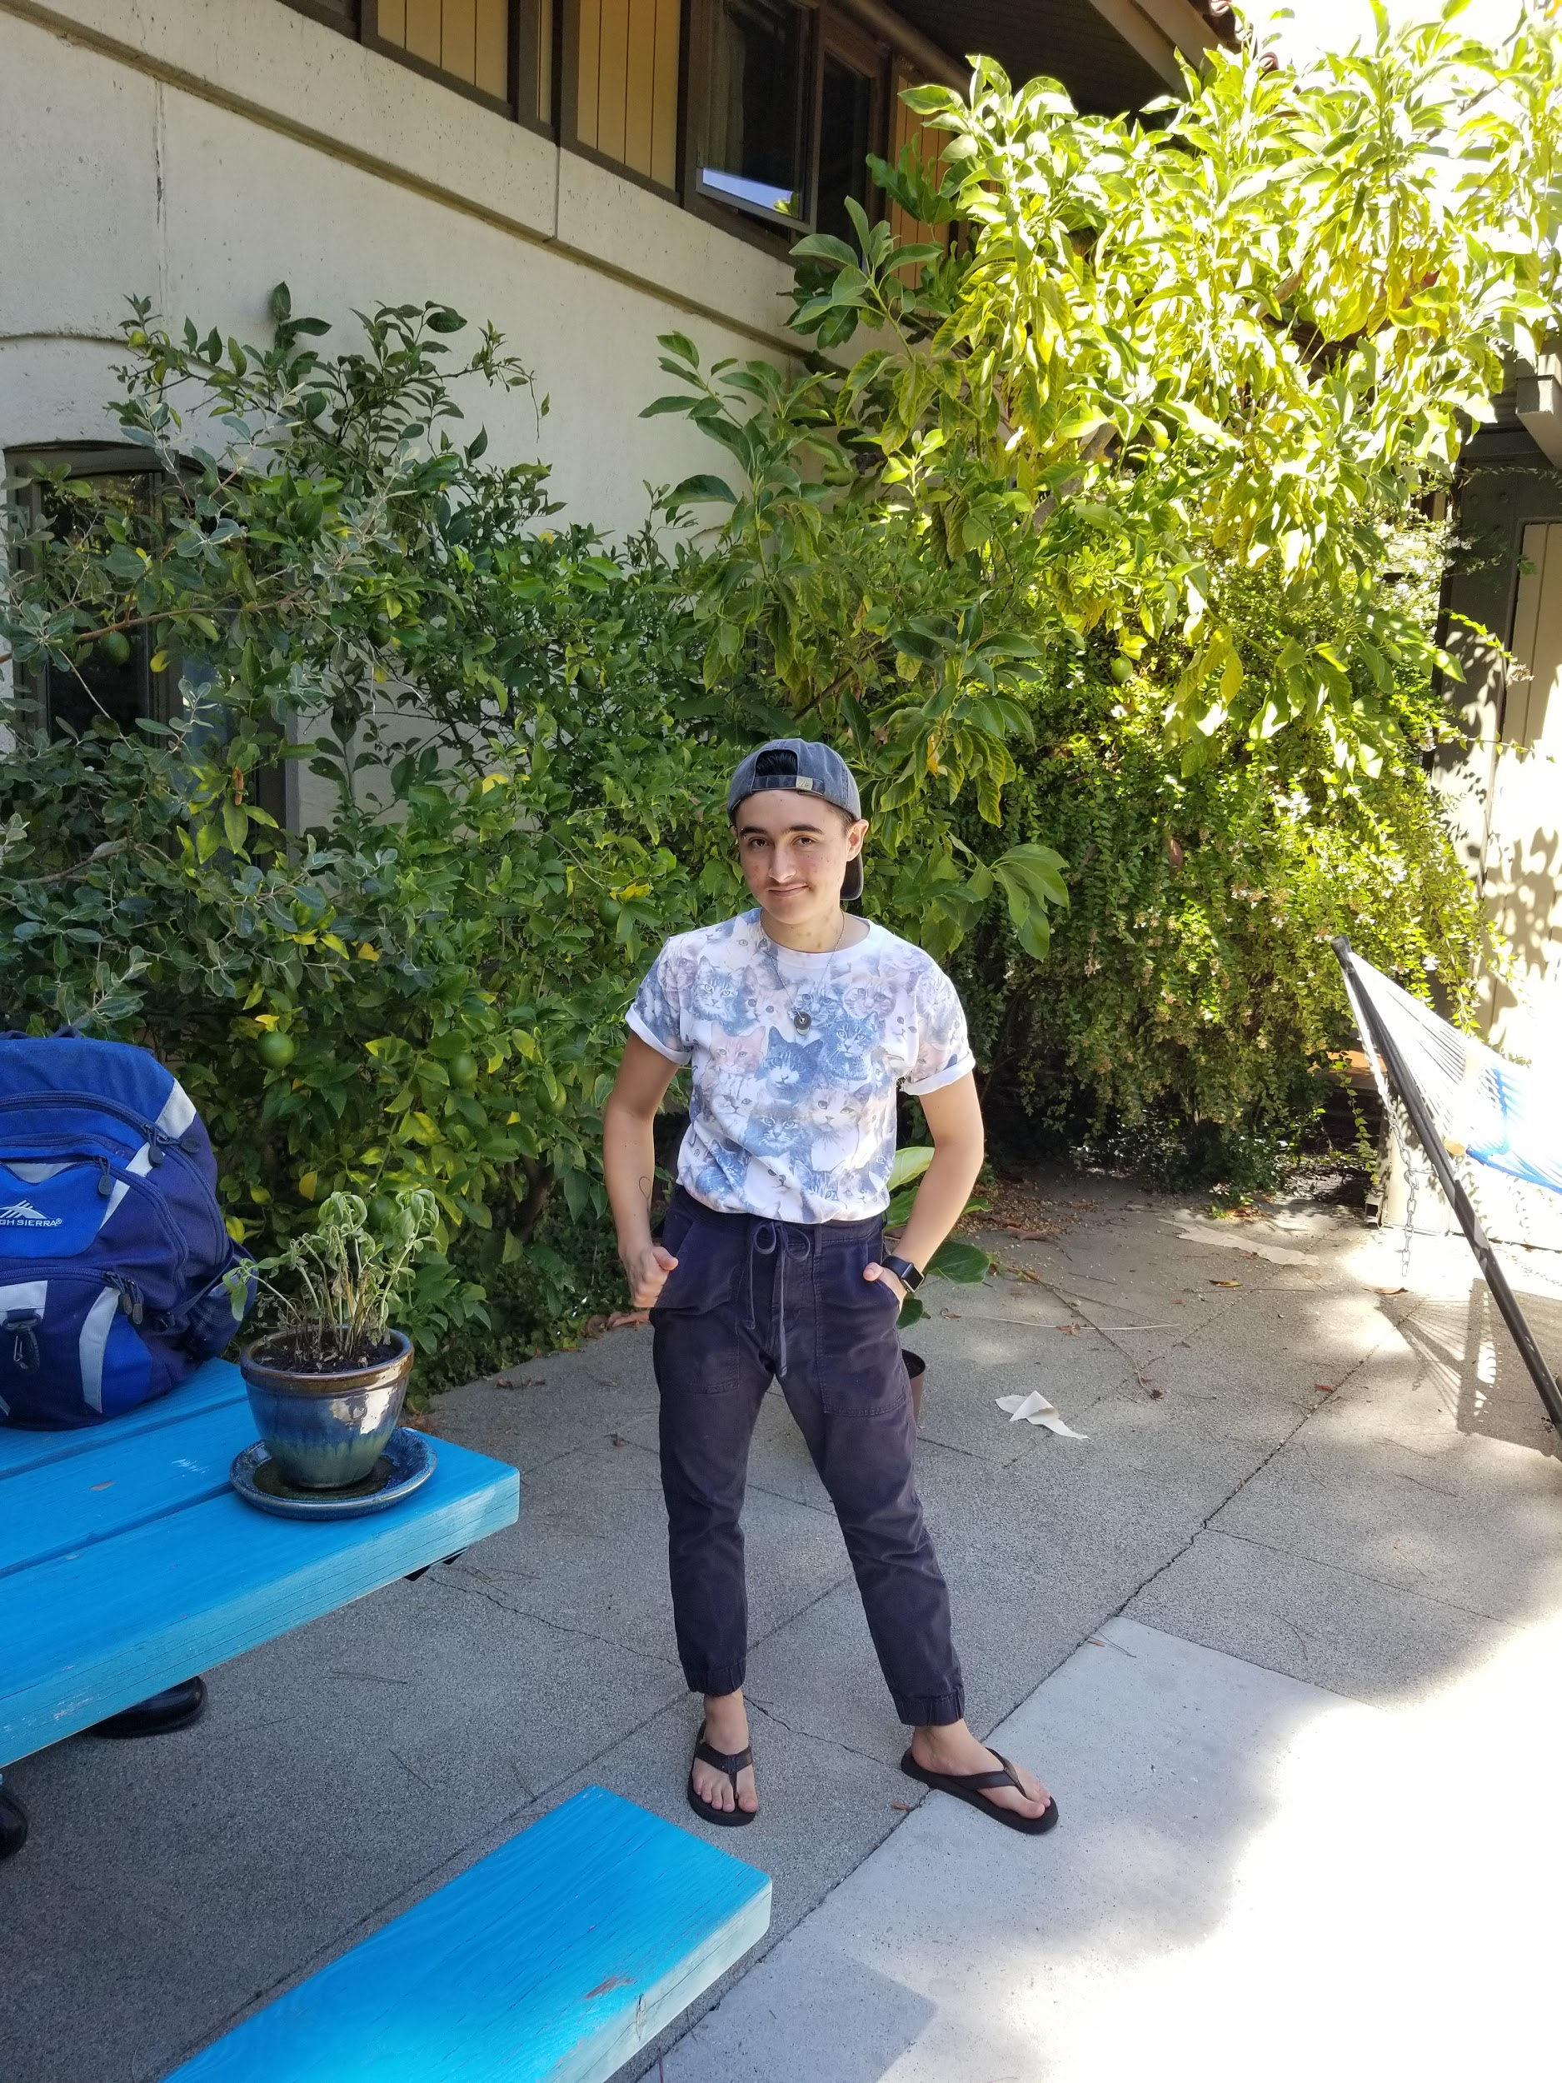

Samuel (#12) was a 4th-year Stanford undergraduate studying CS. They said that for CS, introductory courses foster community and try to “sell you” on the major, while upper level courses lack this support They also spoke about the tension between “hating” discussion section because it was another thing to fit into the calendar, but enjoying and appreciating the chance to discuss class material in a small-group setting and lacking this opportunity in upper level courses without section.

**POVs and HMWs:**

Using Heatmap selection, we selected one interview from Week 1 and two from Week 2 as being the most representative and interesting with respect to our focused domain, and selected several of our brainstormed HMWs for each.

**POV #1: Gabriel**

* We met Gabriel, an experienced humanities professor at Stanford.
* We were amazed to find that, although he loves the utility of technology, he hesitates to use it because it interferes with body language, which he relies on for feedback about student engagement.
* It would be game-changing if students could interact with technology without it blocking their body language, or if body language feedback could somehow be replaced.
* **Top HMWs:**
  + HMW let students look at both their technology and the teacher at once?
  + HMW help professors to read their classroom without body language?
  + HMW let students give their teacher feedback in real time?

**POV #2: Joe**

* We met Joe, a motivated high school student taking community college classes through the Middle College Program at Canada College.
* We were amazed to realize that Joe loves the challenge and engagement of in-class discussion, but that the convenience and flexibility of his online CS course make *it* his favorite class.
* It would be game-changing to simultaneously satisfy his desire for in-depth discussion and flexible time/location.
* **Top HMWs:**
  + HMW make gathering a study group a more fun and interesting process?
  + HMW better integrate remote participants into in-person discussions?
  + HMW allow students to give and receive feedback on work remotely?
  + HMW fit discussion sections into people’s busy everyday lives?

**POV #3: Samuel**

* We met Samuel, a 4th-year Stanford undergraduate, studying Computer Science.
* We were fascinated to find they preferred introductory CS courses to upper-level courses, because of their welcoming and energetic culture and clear support systems.
* It would be game-changing if higher-level classes could retain that culture and support.
* **Top HMWs:**
  + HMW make it easier for students to ask questions without feeling judged?
  + HMW build more connections between introductory and upper-level classes?
  + HMW regain that “freshman energy” in upper-level classes?

**HMWs with the most potential:**

* HMW make gathering a study group a more fun and interesting process? (POV #2)
* HMW fit discussion sections into people’s busy everyday lives? (POV #2)
* HMW regain that “freshman energy” in upper-level classes? (POV #3)

**Brainstorming and Prototypes:**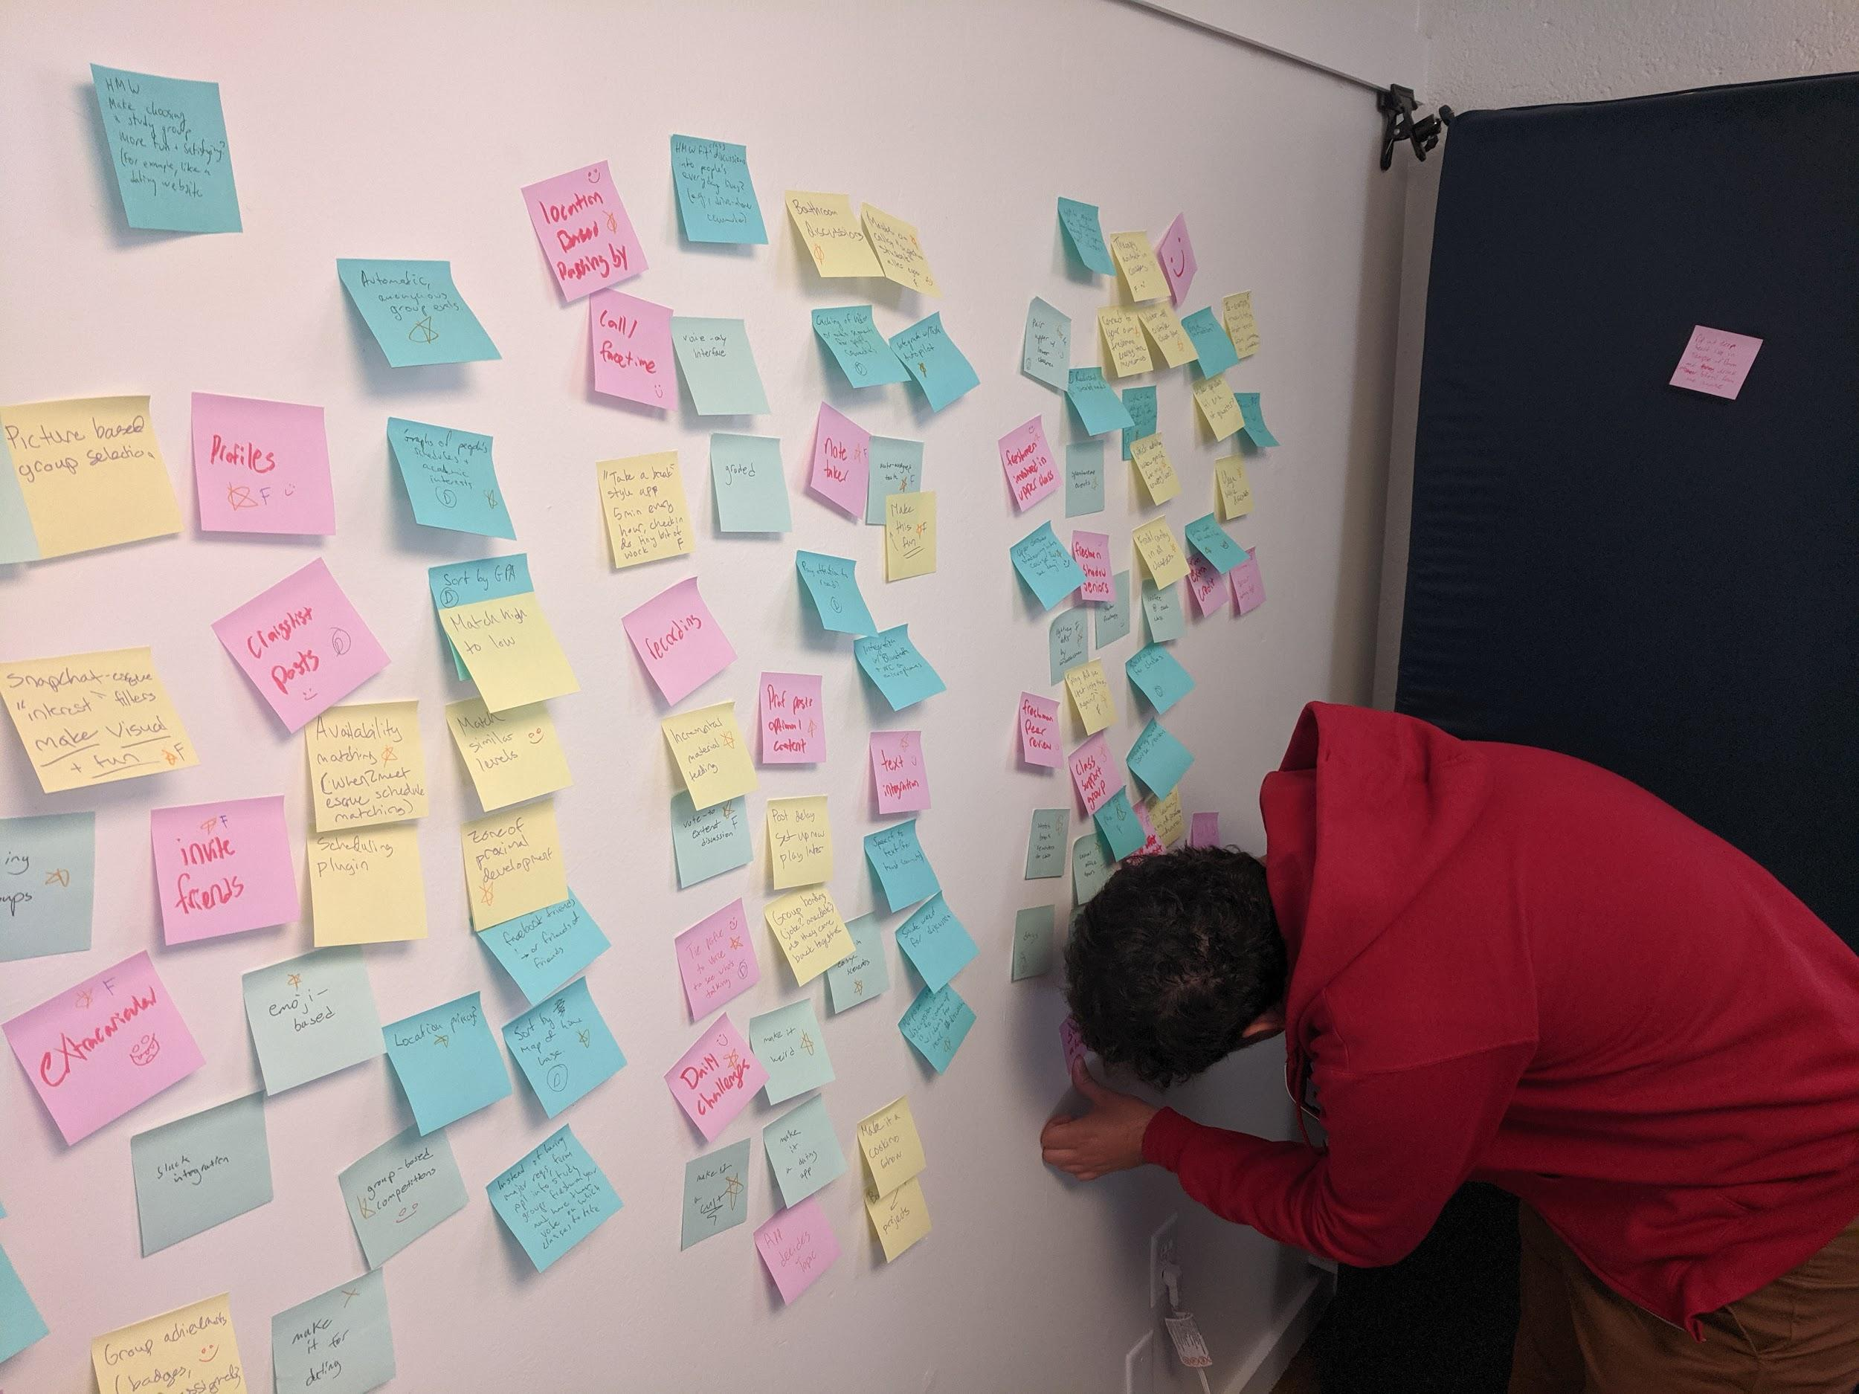

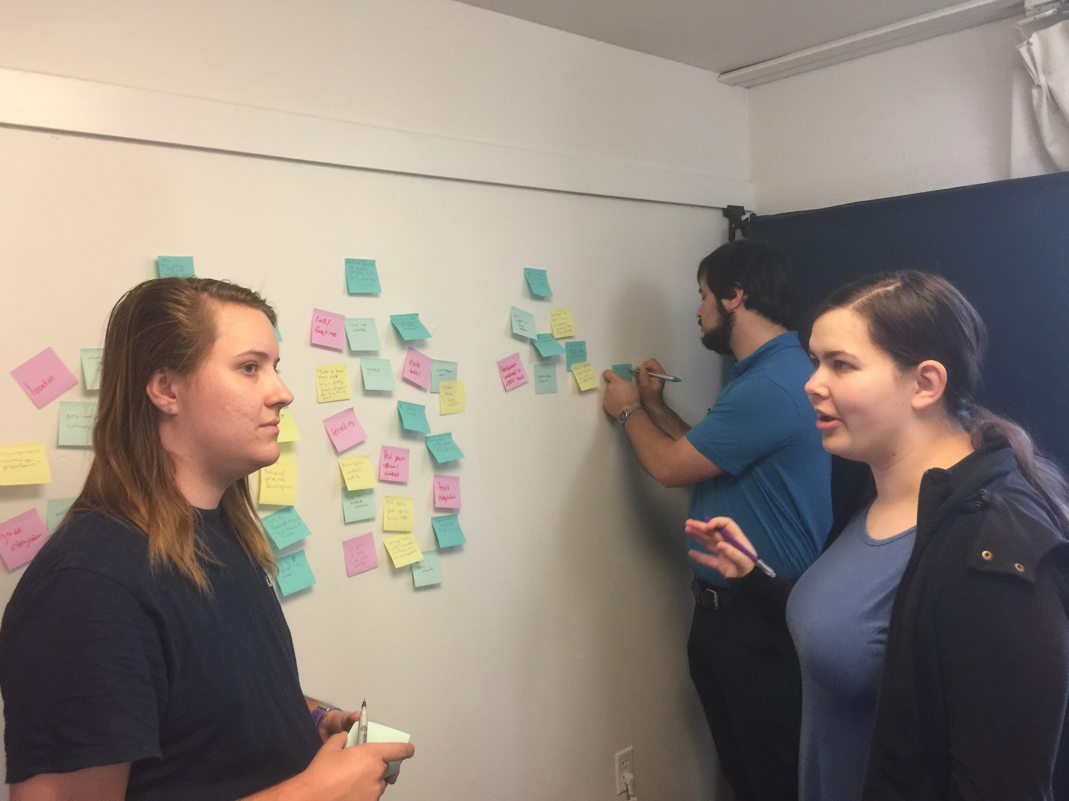

**⬅︎**

*Initial Brainstorming*

➡︎

*Adding additional and Dark Horse ideas*

*Final Organization of Ideas (HMWs at top, Ideas with 3+ votes above line, Ideas organized by descending # of votes going down each column)*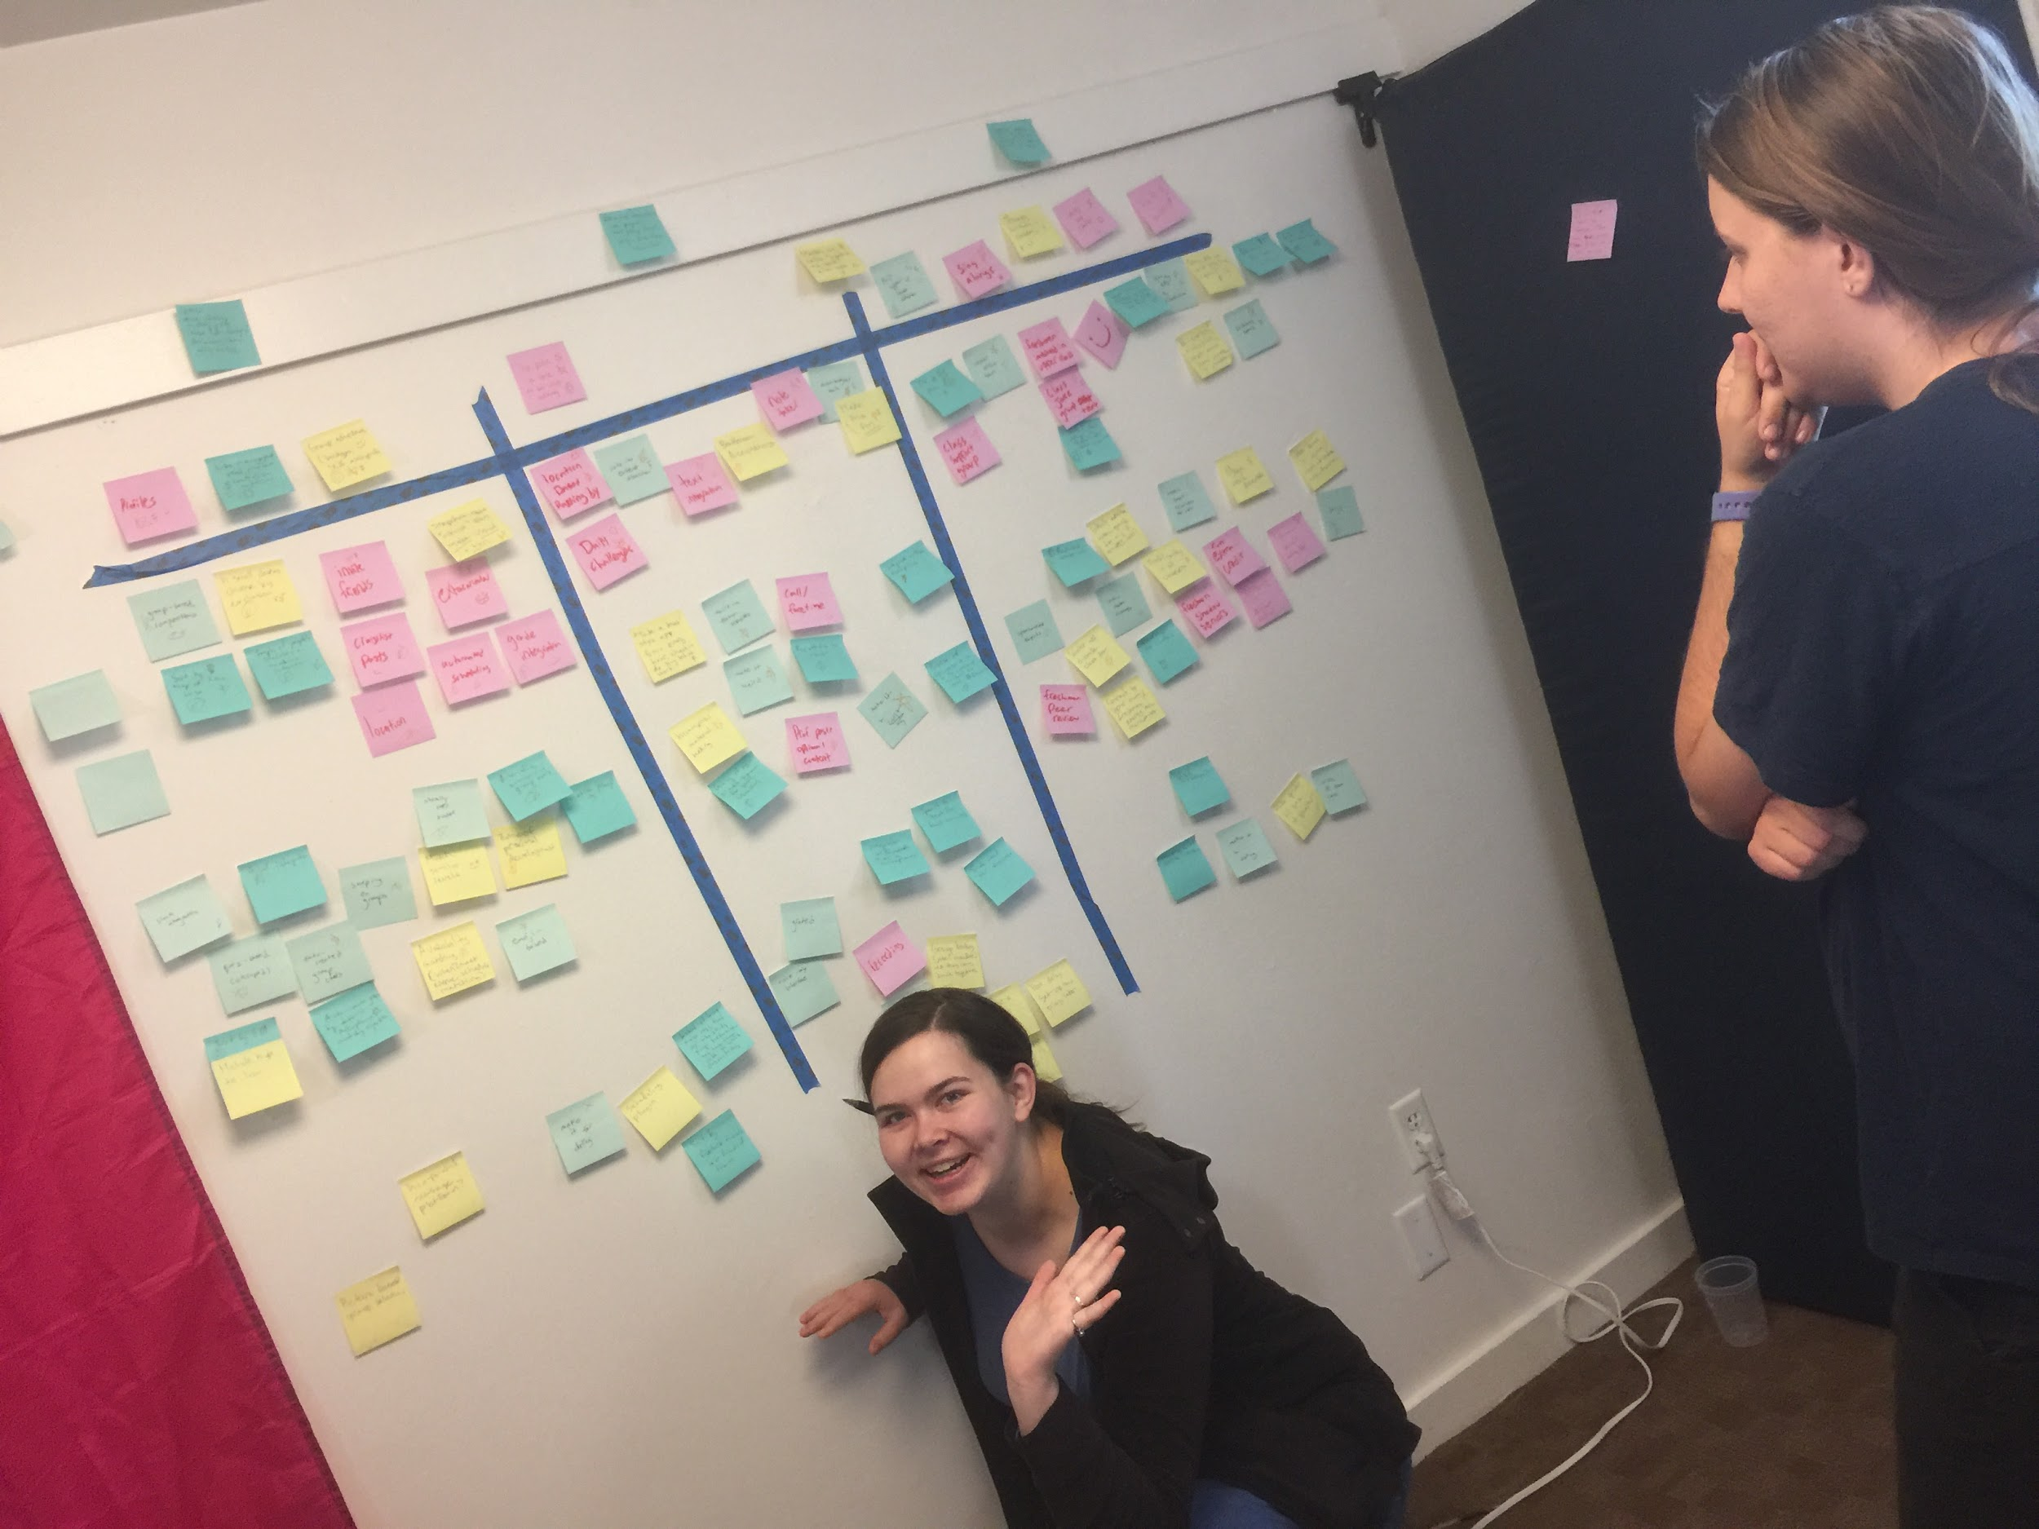

**HMW 1 Experience Prototype — Group Discussion Badges:**

With our first prototype, we wanted to address the process of forming and building cohesion in discussion groups. We assumed that this could be improved by helping students reflect on their discussion experiences and highlight their success.

Our brainstorming produced the idea of having digital “badges” which could be awarded to groups and participants to mark what was successful about their conversations and create positive feeling and group cohesion. We created low-fidelity badges by drawing on index cards and writing short descriptions on the back.

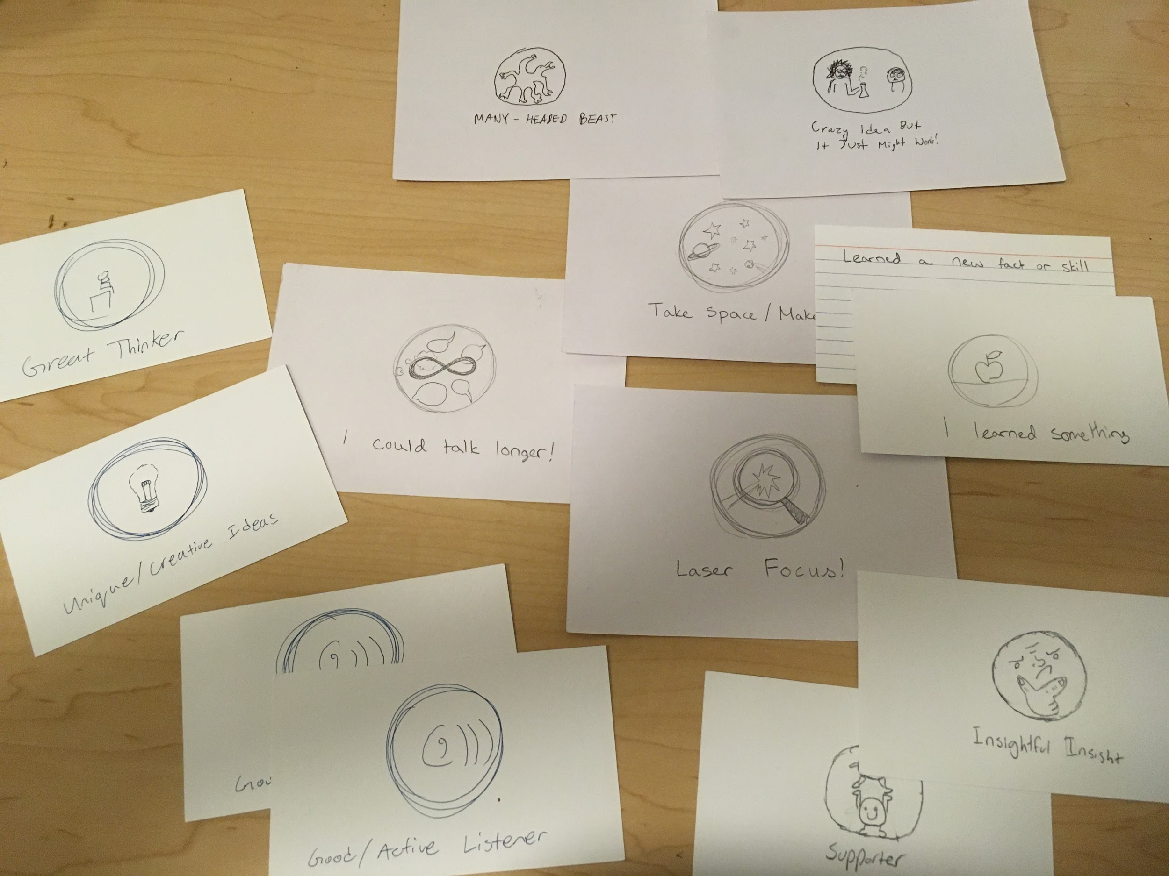

*Index Card “Badges”*

We then tested the badges with our Participant #13, Heather, a junior at Stanford. We first engaged in a 7 minute academic discussion, replicating a literature analysis activity from a humanities course. Fiona and Eli acted as participants in the discussion, while Jake and David observed. After the 7 minutes concluded, we handed Heather the deck of “badges” and asked her to award the ones she thought appropriate.

*What went well:* Heather expressed enjoyment of the discussion section as a whole, as demonstrated by her awarding the “I could have talked longer . . .” badge to the group. She said she thought the badges could work well with a younger age group, potentially as an introduction to group dynamics: “maybe a nice reminder of what a good group discussion is.” She also gave feedback about the mechanism for awarding badges, stating: “I think group badges are nice, but it would almost be nicer if the teacher handed them out.”

*What could be improved:* Reciprocally, Heather said “it felt a little silly” to be awarding badges to individual group members and that it felt “a little strange and very subjective” to be “grading” our own performance: “If I hand it to myself, I’m . . . just saying this because that’s what I wanted to be.” When asked about the potential of the badges to be used outside of class, for group work, she responded “I don’t know if it would be executed well without oversight of a . . . teacher or a teacher’s assistant . . . people are unlikely to hand out badges . . . it’s unlikely that they would individually award badges.”

*Our Conclusions:*  This prototype went against our assumption that reflecting on and affirming positive elements of group conversation would be a uniformly enjoyable experience for group members. A more successful iteration of the badges might see them assigned by a third party playing an instructor or TA. While they could certainly still be useful in encouraging positive group dynamics, they don’t apply as much as we first hoped to our specific POVs and HMWs.

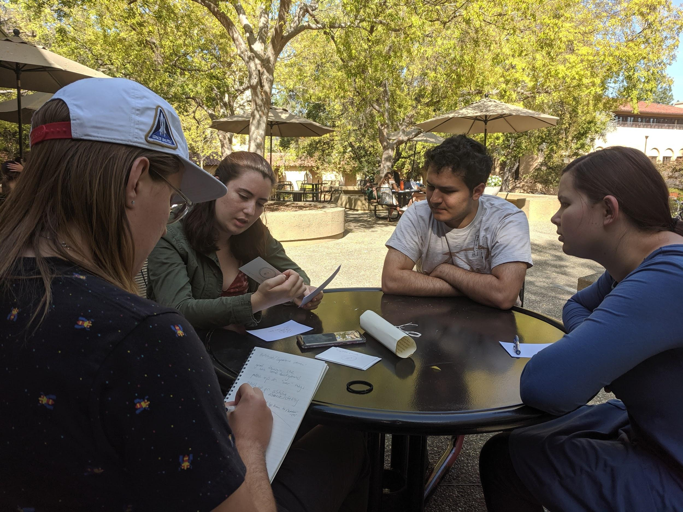

*Testing our Group Discussion Badges Experience Prototype*

**HMW 2 Experience Prototype — Remote Discussion during Task Completion:**

Based on interviews with both Joe (POV #2) and Samuel (POV #3), we wanted to find ways to better incorporate discussion sections into students’ busy schedules. In our brainstorming, we discussed how we might capitalize on unexploited “pockets” of time such as a commute or while completing a physical task to fit in discussion without taking up otherwise unscheduled time. We assumed going in that conversation might grow stilted if participants were too distracted with navigating travel or completing some other task, and we wanted to test the feasibility of remote discussion during those “pockets.”

For this prototype, we recruited one Stanford student: Luke (Participant #14) and one non-Stanford recent graduate: Chris (Participant #15) whom we met at Tresidder. We presented Luke and Chris with the introduction to the novel *Her First American* by Lore Segal and asked them to discuss their interpretations over a phone-based video call while Luke walked from Tressider to the Stanford Post Office to check the mail and then returned. Jake observed Luke, while Eli and David observed Chris, who stayed at Tresidder.

*Introduction to* Her First American *Luke, participating at Tresidder*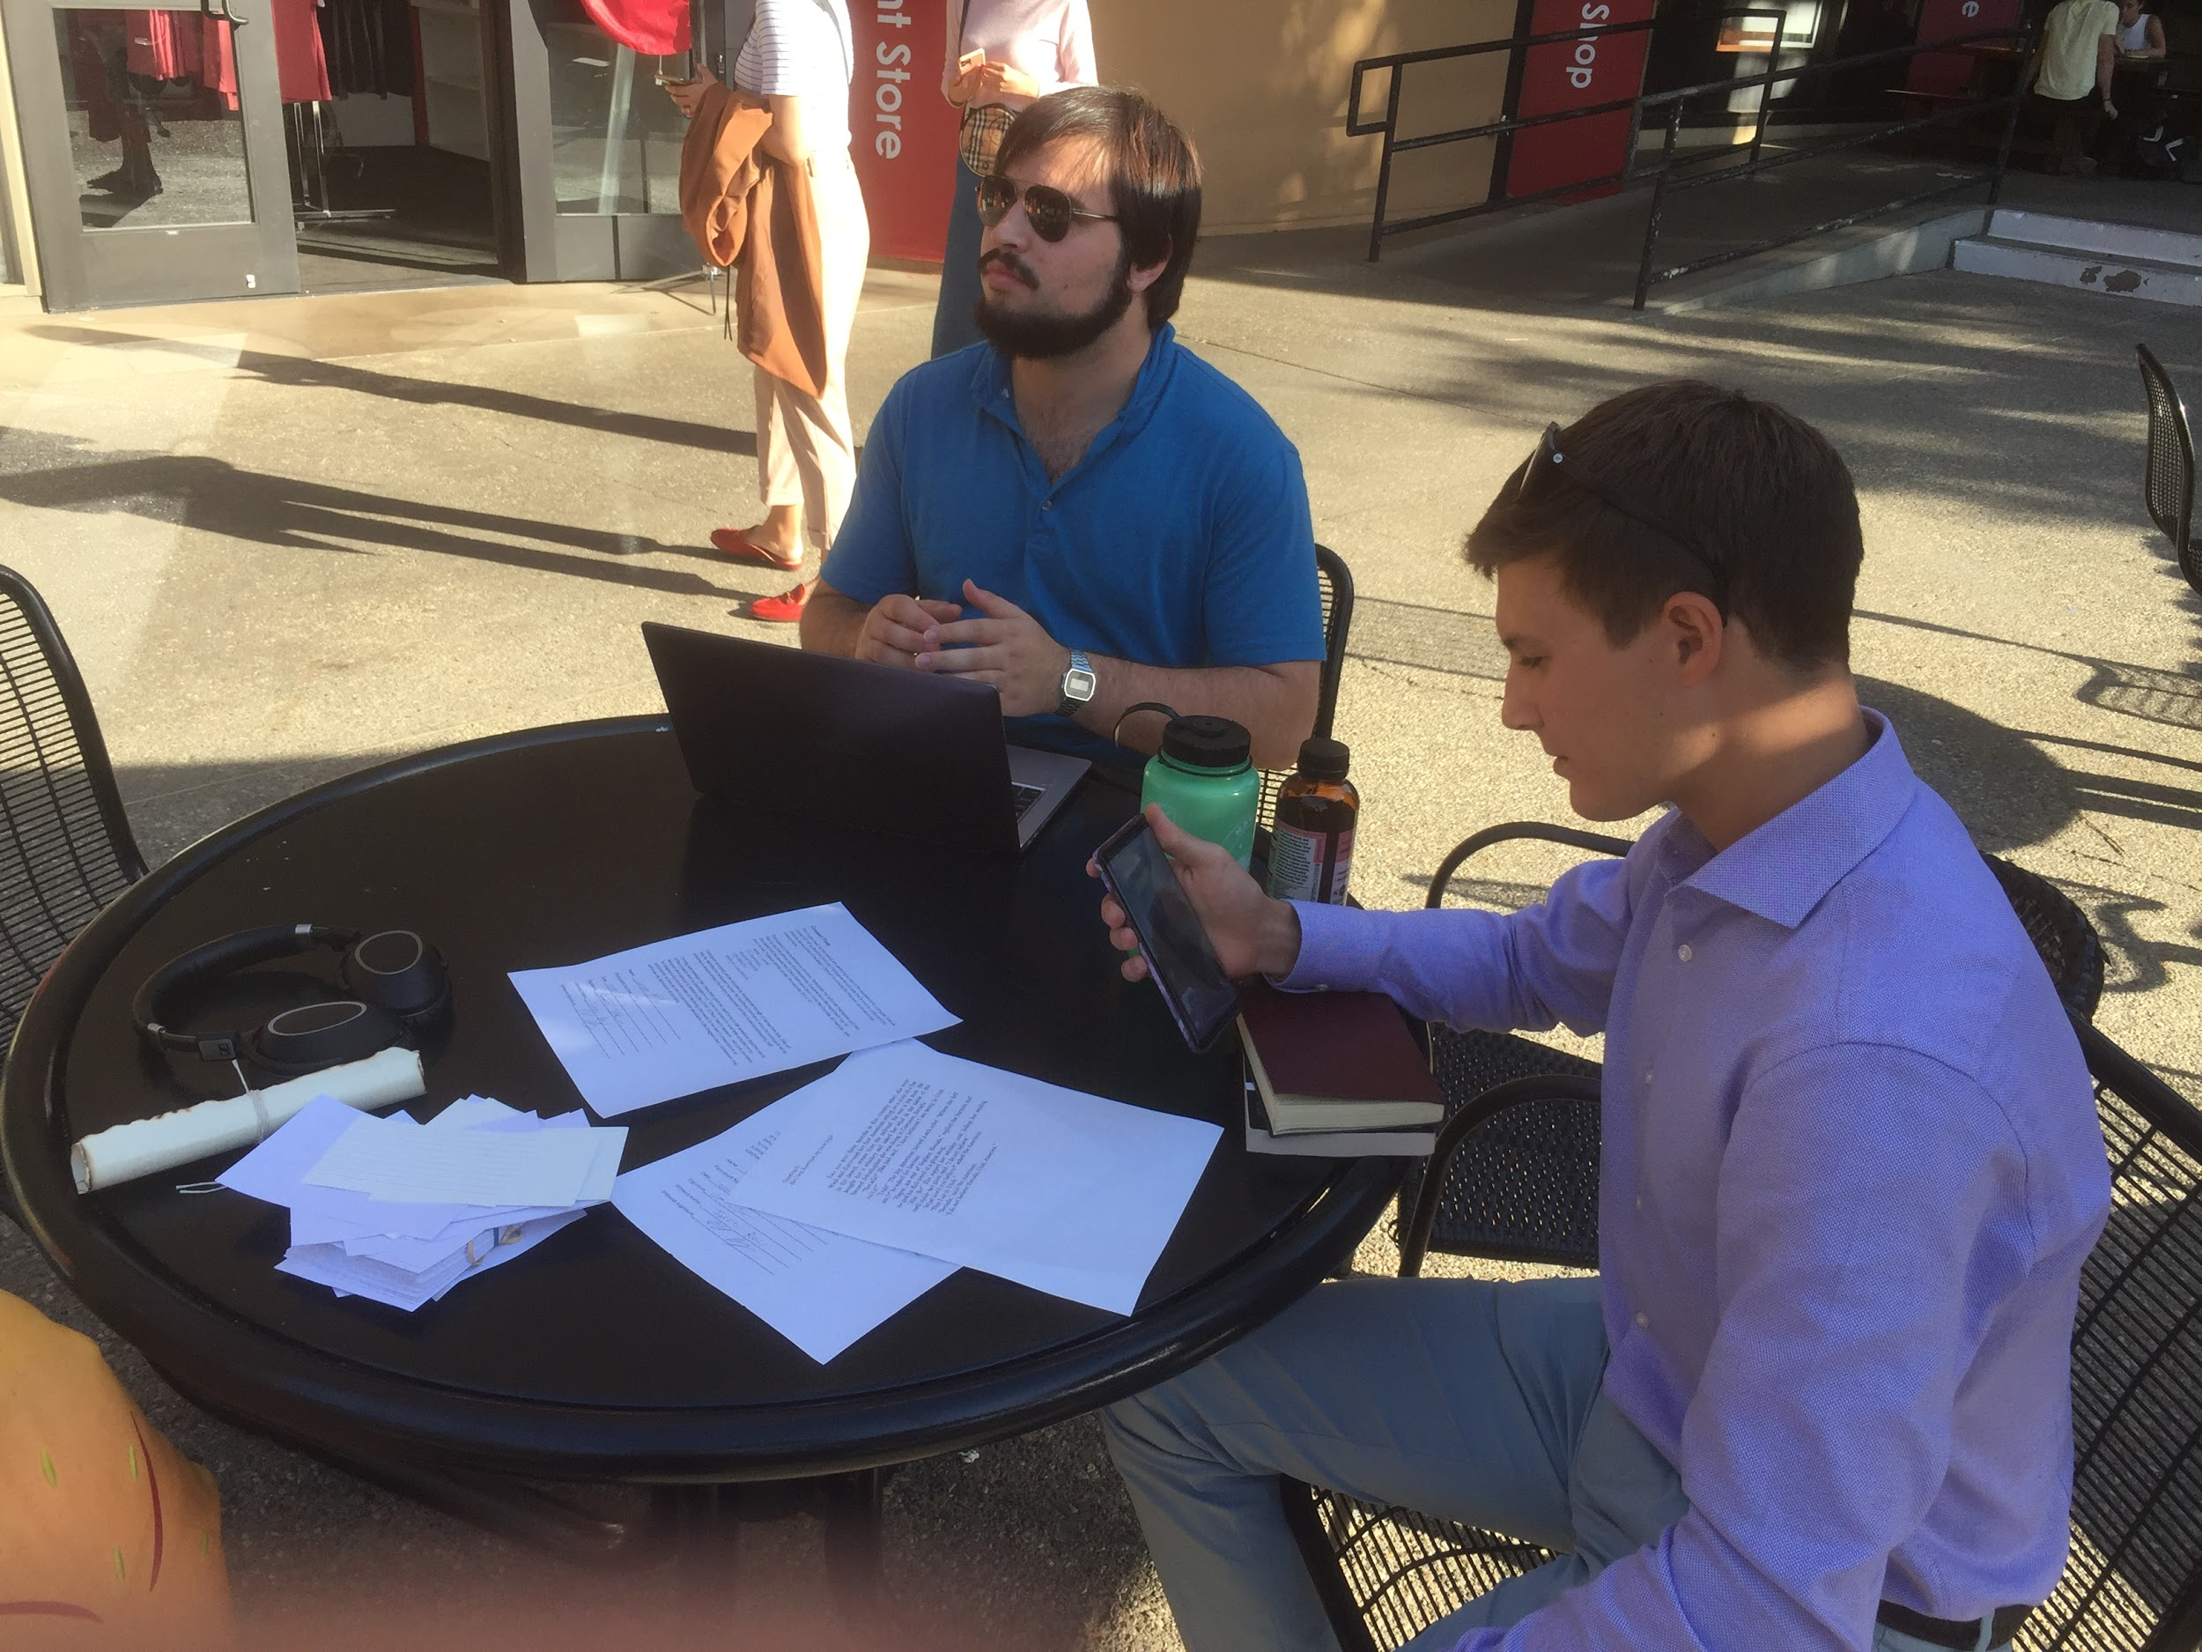

*What went well:* Both Luke and Chris felt that the conversation was productive and interesting, and the group agreed. Despite some connectivity issues, they were able to carry out a reasonably complete analysis of the excerpt in the time it took Luke to walk to the post office (~7 minutes), check the mail, and return: Luke said that he felt like the conversation was naturally wrapping up at the end.

*What could be improved:* Luke mentioned that it felt awkward to be on speaker while in a public space. While Chris was impressed with how well Luke kept up with the conversation, there were lulls and stilted periods, especially during the period when Luke was actively checking the P.O. box. Both participants also mentioned that it might have been nice to have more people involved in the discussion.

*Our Conclusions:* We were surprised by the quality of their conversation and analysis and how positive they both felt about it. Our theory that we can exploit “pockets” of time was supported and we want to further explore how we can make the discussion smoother and more comfortable

**HMW 3 Experience Prototype — Senior-Freshman Meet-up:**

For our final experience prototype, we wanted to capture the idea of bringing “freshman energy”—which we loosely defined as curiosity and enthusiasm—to upperclassmen. We made two assumptions: upperclassmen do not interact much with freshmen and interacting with freshmen could help stressed-out upperclassmen regain enthusiasm for classes and college life in general.

To test this, we recruited Kamaria (Participant #17), a Stanford senior and RA in Roble, and Lim (Participant #16), a Stanford freshman from Singapore. We asked them to talk about “the most interesting thing you learned last week.”

*What went well:* Both participants concluded it was a worthwhile experience and would like to speak more. Lim appreciated the perspective of a senior. They had a productive discussion and covered a variety of topics. Both touched significantly on their present experiences; Lim spoke of his excitement and NSO experiences, while Kamaria spoke of her stress regarding impending graduation.

*What could be improved:* Kamaria mentioned that her friends do not really speak to freshmen, and Lim said that approaching a senior was intimidating and difficult. Kamaria is an RA, and so further testing should be done to see if non-RAs are willing to engage and if they find the experience valuable.

*Conclusions:* Our first assumption was strongly supported. Our second assumption was supported, but it remains unknown how generalizable it is. We want to further explore how we could facilitate these discussions and how we could guide them to be most impactful.

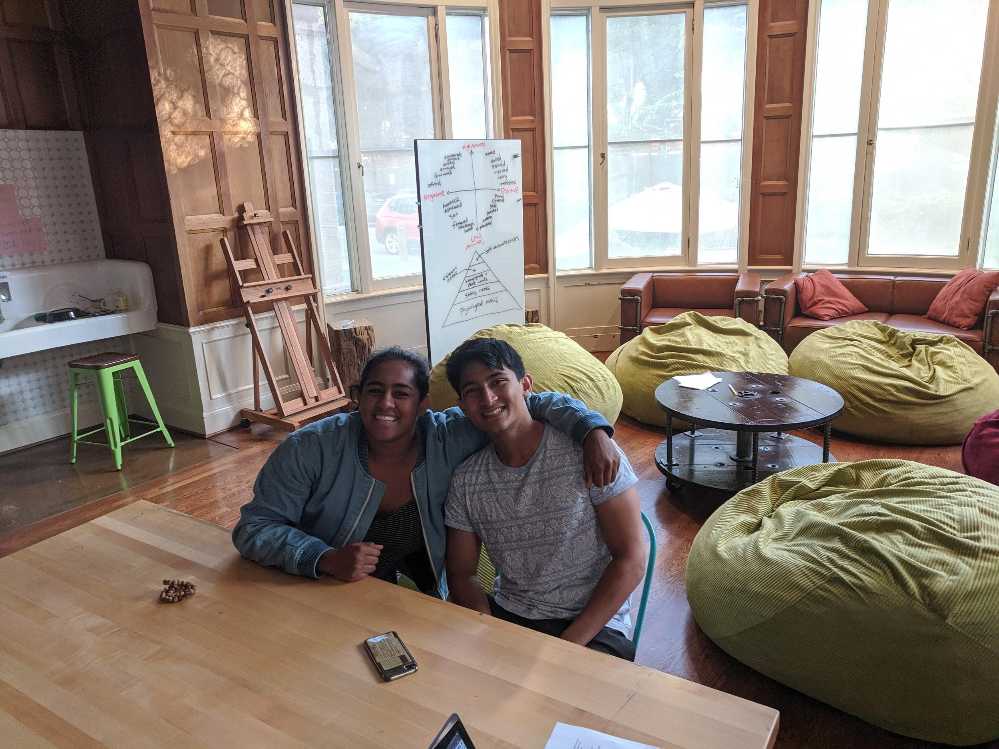

*Kamaria and Lim*

**Takeaways and Next Steps:**

Of the assumptions and prototypes we tested, the most successful was #3, the Senior-Freshman Meetup, followed by #2, Remote Discussion during Task Completion. Both of these prototypes seem promising in terms of increasing students' ability and desire to engage in academic discussions. Based on the success of prototypes #2 and #3 versus prototype #1, we plan to focus on helping students connect and find time for these discussions, as opposed to adding any complicating factors to the discussions themselves. Ideally, our interface—whatever form it takes—will be so smooth to interact with that it will become the figuratively invisible background for the great conversations and learning opportunities it facilitates.